VANKLEEK HILL FAIR ENGLISH HORSE SHOW ENTRY FORM 2019
8
33

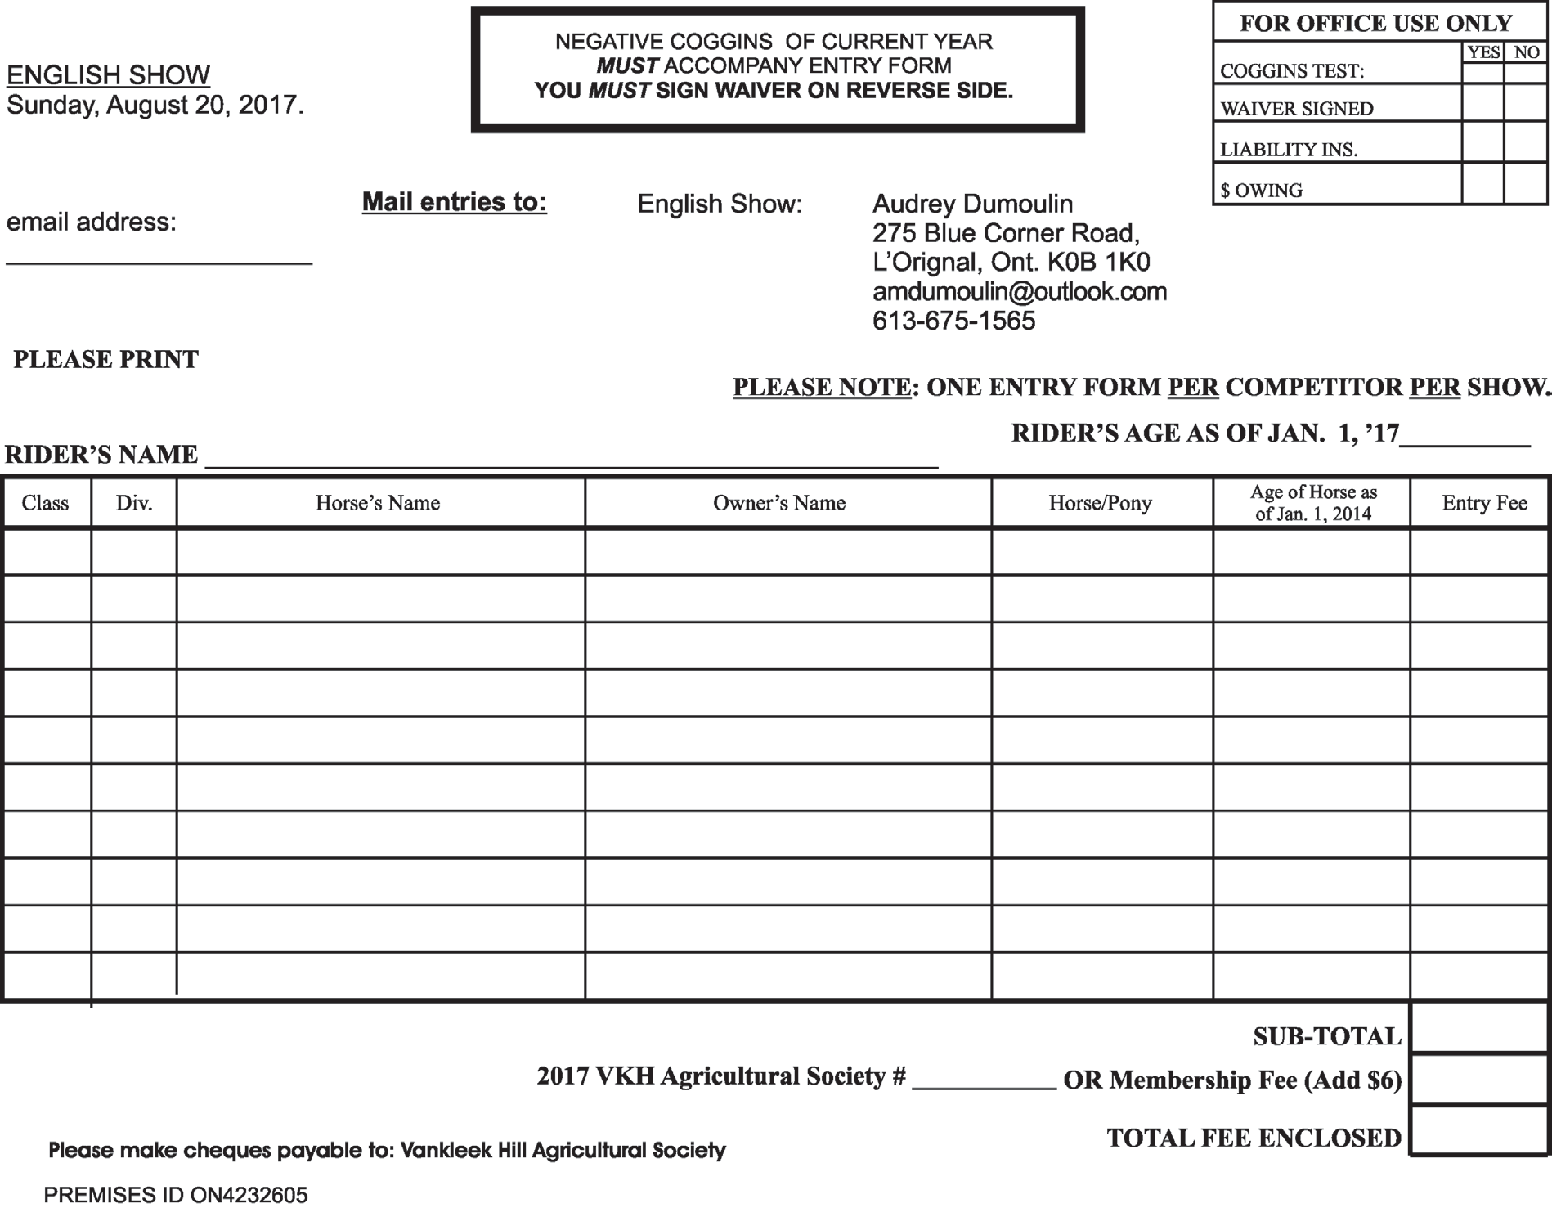

Sunday, August 18, 2019

RIDER’S AGE AS OF JAN. 1, 2019

